Wall name:  Memorial wall |  | Wall type:  Precast concrete |  | Highway/Road  Kilmore and Manchester | RP:  15263 | OSN:  FG 234
Length: 50 m |  |  | GPS (lat,long): -43.5266818,172.6422713
Max height: 0.75 m |  |  | Owner: Local Authority
Average height: 0.75 |  |  | Weather: Sunny, Fine
Angle to vertical: 0 ˚ |  |  | Offset from highway centreline: 6.5 m
Retained material: Earthworks, second wall for path.
Inspector: Mark English |  |  | Inspection type: Routine
Date: 22-Jul-2016 | Date (mth/yr): |  | Next inspection type: General

Photos
Item no. | Element, remedial work and element photos
- 1 | Retaining wall - Primary - Routine maintenance (Low)  Regular spray with moss killer
- 1 | Carriageway - Top of wall - Scheduled maintenance (Medium)  Re-fit anti-skateboard cleats.

Supporting Photos

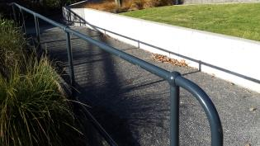
Guardrail
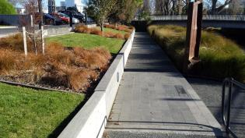
General view of structure.

