Bridge Name:  Harper Avenue |  | Bridge type:  Single span |  | Highway/Road  Carlton Mill / Rolleston Ave | RP: | BSN:  CC23
Deck width: 10 m |  |  | GPS (lat,long): -43.5208303,172.6255355
Total Bridge length: 16 m |  |  | Owner: Christchurch City Council
Span: 1 of 1 |  |  | Weather: Sunny, Fine
Span length: 16 m
Inspector: Mark English |  |  | Inspection type: Routine
Date: 01-Jun-2016 | Date (mth/yr): |  | Next inspection type: General

Photos
Item no. | Element, remedial work and element photos
- 1 | Secondary - Other (incl. deck) - Scheduled maintenance (Medium)  Resurface and investigate drop
- 1 | Abutments - Routine maintenance (High)  Investigate cracks  Reskim concrete
- 1 | Painting : Barriers / guardrails - Scheduled maintenance (Low)  Scrub and clean

- 1 | Access / walkways / gantries - Scheduled maintenance (Medium)  Chipp off spilled concrete
- 1 | Guardrail / handrail / safety fences - Scheduled maintenance (High)  Fix guard fence in place.

Supporting Photos

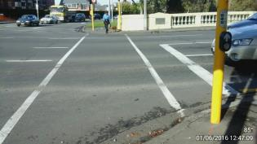
Bealey Ave approach
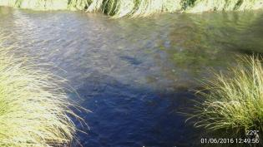
Riverbed upstream
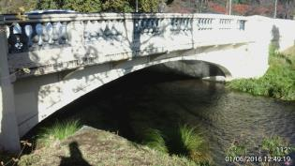
Side view of span
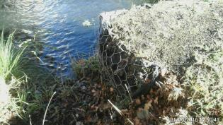
Erosion protection

