Project: Main Depot - New Build | Project Ref: PRJ-123456
Client: City Council | Client contact: Clive, 021 345 567
Site Address: 55 St Asaph Street | Date on Site: 12-Feb-2020
Applicator Company:  Bob Painting | Job Specification:  TG5647
Temp at start: °C | Humidity at start: %
Meter ref: PSK5678

Ground floor
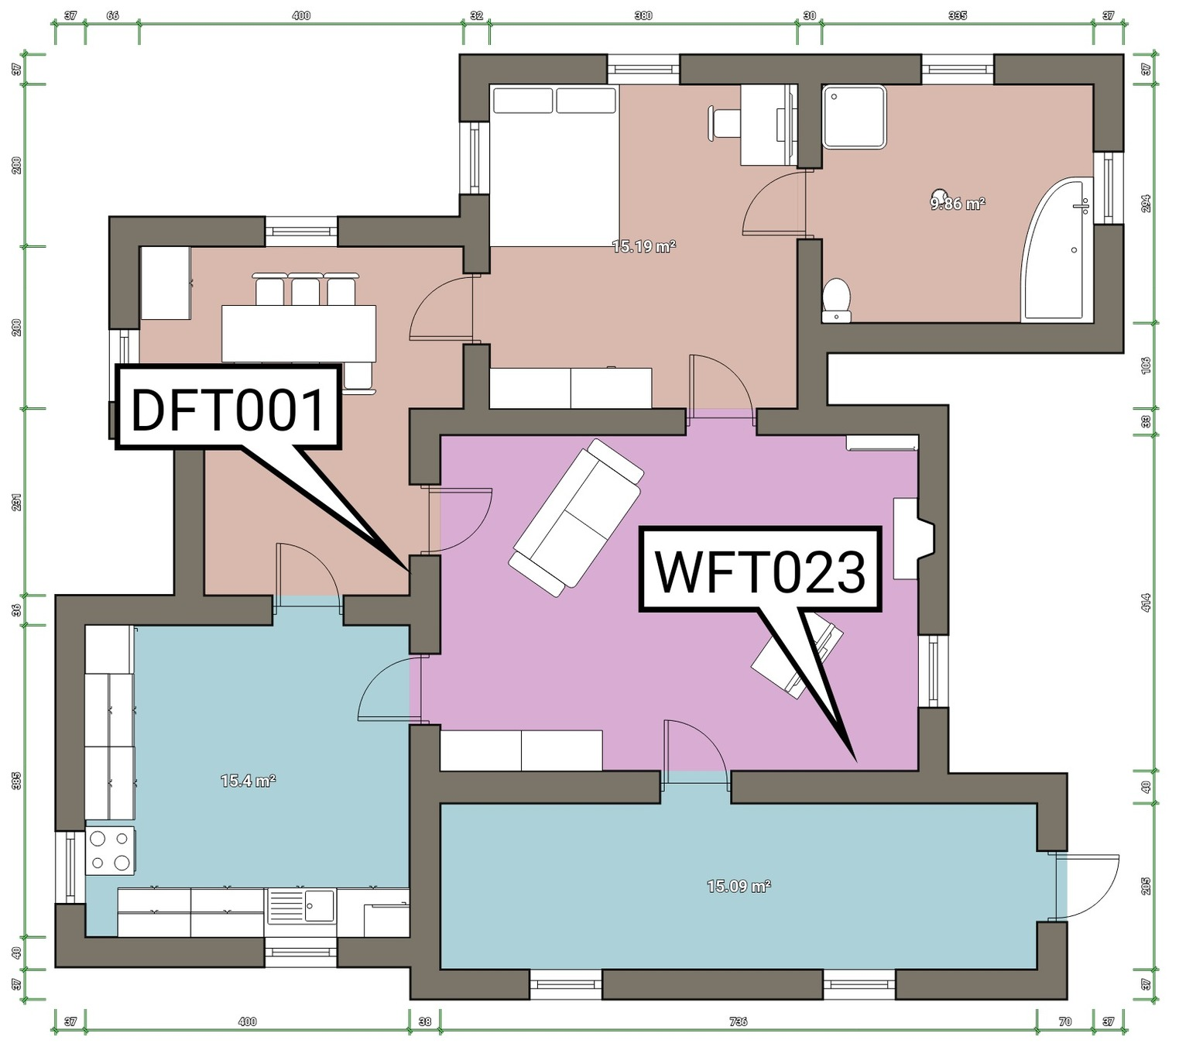

Film Inspections
Ref: Dry Film: 001
Time: 3:14 pm | Location: Kitchen
Primer, Tar | Min: 25 μm | 32 μm
Readings: 25 | Max: 39 μm
Readings batch: | Std Dev: 4

Comments
No notes recorded
Remedial Actions
No action required

Ref: Wet Film: 023
Time: 3:16 pm | Location: Bedroom
Applicator's Name: Bob |  | Thickness
Temperature: °C |  | 5 μm
Humidity: %

Comments
Nice
Remedial Actions
Do it again

