Pre-sale Inspection of
195 Bolton Crescent
Wardley
Christchurch
for
Jane Doe

Undertaken on 02-Sep-2014 by Mark English

Table of Contents
Access 3
General Site 3
Property Exterior 4
General Observations 4
Specific Exterior Points 4
Roof 4
General Observations 4
Specific Roof Points 5
Property Interior 5
General Observations 5
Specific Interior Points 5
Roofspace 6
Underfloor 6
Other Items of note 7
Additional Photos 7
Office. 7
Office again 7

Access
driveway
Condition:
Average - at least one item requires immediate attention
Action required:
weeding and polishing
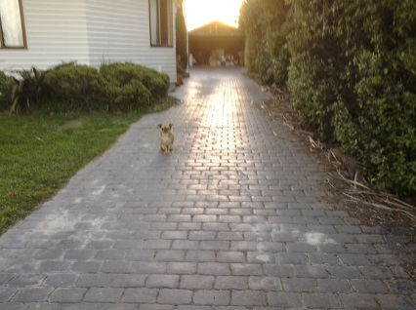 | 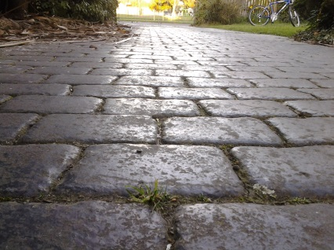 | 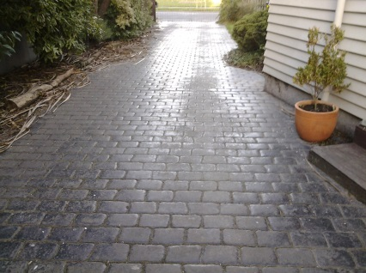
Weeds growing between cracks, slightley scratched on surface | weeds and scratches | scratches

General Site
A bit shabby and needs moving
Condition:
Poor - many items require immediate attention
Action required:
painting, mowing
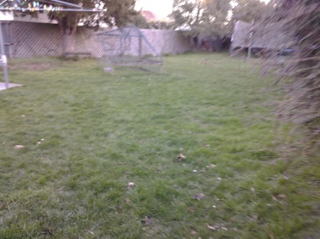 | 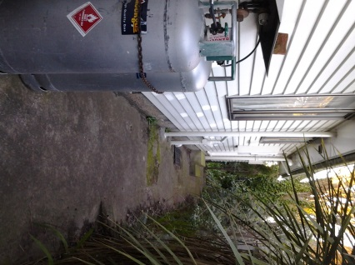 | 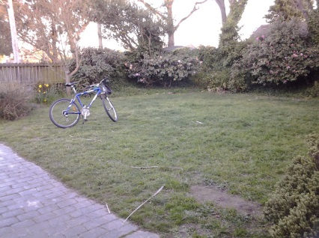
needs mowing | needs paint job | slightly over grown plants

Property Exterior

General Observations
needs better paint job and has good gas heaters
Condition:
Average - at least one item requires immediate attention
Action required:

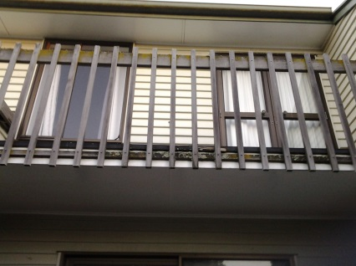 | 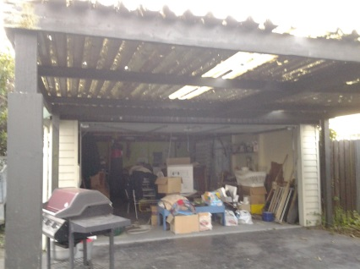 | 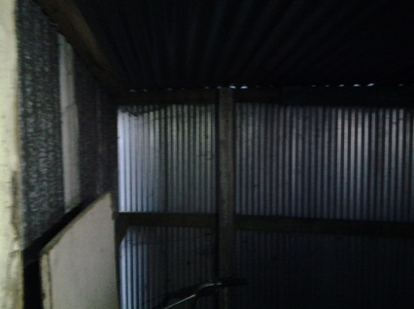
balcony | garage roof

Specific Exterior Points
Other rear wall
Condition:  Average - will require attention within a year or so | 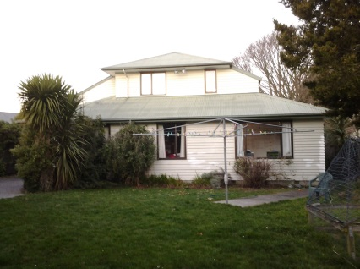  Proximity of washing line to house
Action required:
Minor paint work

Roof

General Observations
Reasonable condition. Paint on tin.
Condition:
Poor - many items require immediate attention
Action required:
New cover on shelter
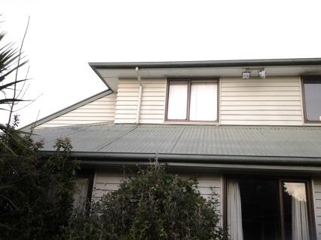 | 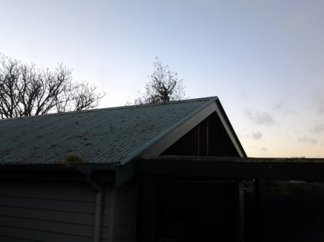 | 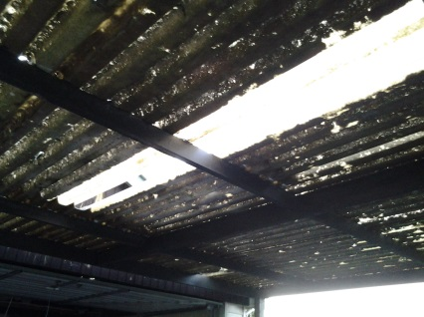
Rear face showing pitch | The garage. | Garage cover in need of repair

Specific Roof Points
Spouting north wall
Condition:  Good - condition is acceptable | 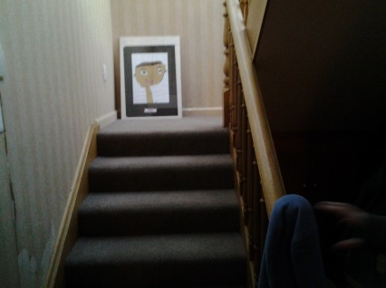  staircase
Action required:
decent staircase, could use polishing on rails

Property Interior

General Observations
bedrooms have a good paint job, could use better carpets
Condition:
Average - at least one item requires immediate attention
Action required:
new lighting and carpets
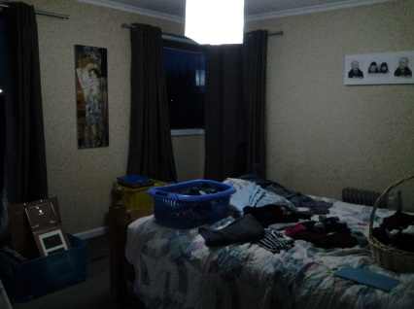 | 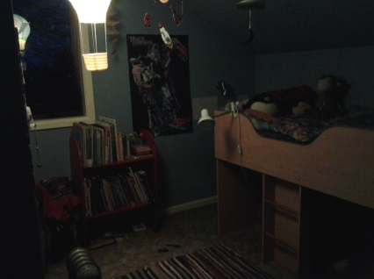 | 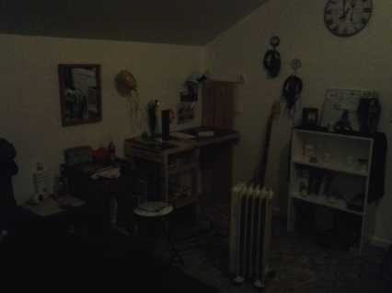
master bedroom needs to be tidied | small bedrooms 1 needs better lighting | small bedroom 2 has a good paint job but needs new carpet

Specific Interior Points
Shower room shower room
Condition:  Poor - requires immediate attention | 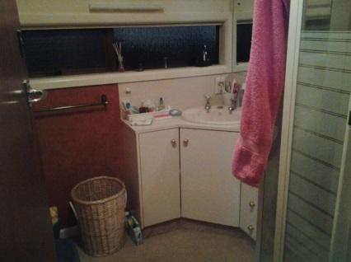  roof needs cleaning
Action required:
cleaning

Kitchen
Condition:  Good - condition is acceptable | 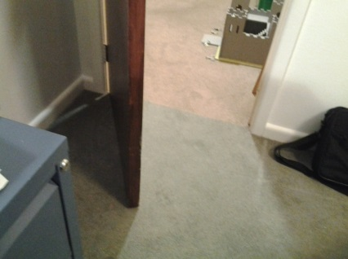
Action required:
none

Roofspace
Dry. Insulated to depth of 15cm
Condition:
Very good - little or no remedial action required
Action required:

Underfloor
Dry. No leaks. Underfloor insulation.
Condition:
Very good - little or no remedial action required
Action required:

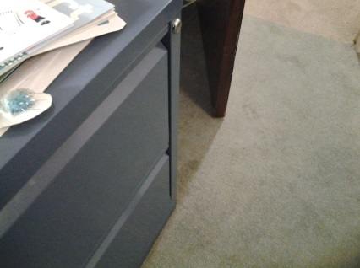
Polystyrene insulation in place.

Other Items of note

Balcony outside upstairs rumpus room.
Condition:  Poor - requires immediate attention | 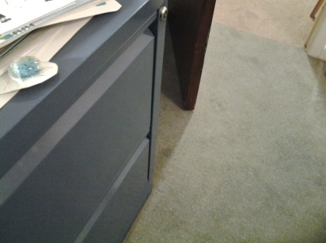  Butyl finish needs replacing
Action required:
Butyl finish needs replacing

Additional Photos

Office.
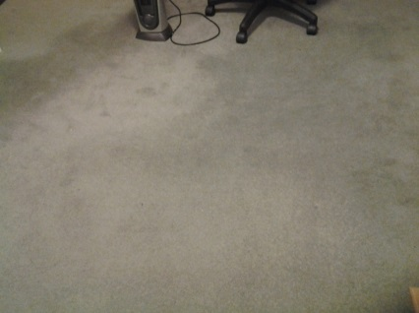

Office again
