Property Inspection for
65 Festive Street
On behalf of
Bob Jones
Tenant
Mr & Mrs Wilson

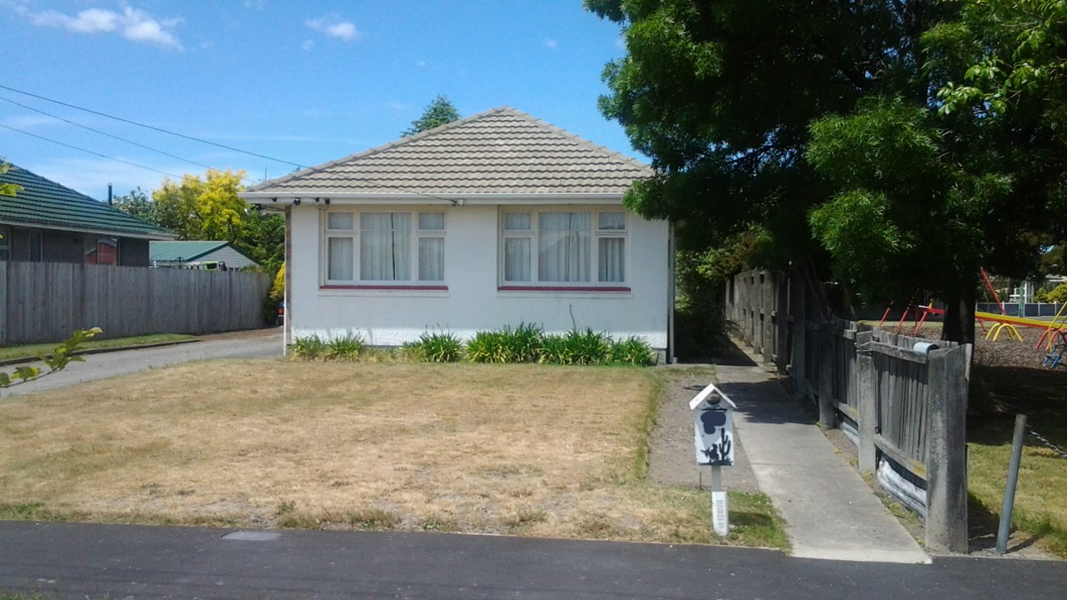

Undertaken on 12-Aug-2015 by Fandango Smith
This report is intended to avoid disputes.
This should be used to record the condition of the property at the start of the tenancy. The Landlord (L/L) should fill out this form, and the Tenant (T) tick the appropriate box if they agree with the condition assessment, or record any damage or defects.
 |  | CONDITION ACCEPTABLE?
 | ROOM AND ITEM | L/L | T | DAMAGE/DEFECTS
Lounge - | Walls/Doors | Good |  | Minor scuff marks around door frames.
 | Light/Power points | Very good |  | Light switch painted over.
 | Floor/Floor coverings | Good
 | Windows | Poor
 | Blinds/Curtains | Average |  | Cigarette burns on right side.
 | Chattels | Heat pump on wall above patio doors.
 | Notes on room | Carpet throughout

Kitchen - | Walls/Doors | Poor
 | Light/Power points | Very good
 | Floor/Floor coverings | N/A |  | Lino scuffed in entranceway.
 | Windows | Very good
 | Blinds/Curtains | Poor
 | Cupboards | Good
 | Sinks/Benches | Good
 | Oven/Cooker | Very good |  | Oven knob loose.
 | Refrigerator | Average
 | Dishwasher | Average
 | Chattels
 | Notes on room

Dining - | Walls/Doors | Poor
 | Light/Power points | Very good
 | Floor/Floor coverings | Very good
 | Windows | Very poor
 | Blinds/Curtains | Missing
 | Chattels | Curtains  Rug
 | Notes on room

Bathroom - Main | Walls/Doors | Very good |  | Mould on back wall.
 | Light/Power points | Poor
 | Floor/Floor coverings | Very good
 | Windows | Poor |  | Window frame rotted in lower right corner.
 | Blinds/Curtains | Missing
 | Mirror/Cabinet | N/A
 | Bath | Good
 | Shower | N/A
 | Wash Basin | Average
 | Toilet (WC) | N/A
 | Chattels
 | Notes on room | Just bathroom.

Bedroom - Master | Walls/Doors | Poor |  | Plasterboard worn where bed-head used to be.
 | Light/Power points | Average
 | Floor/Floor coverings | Good
 | Windows | Poor |  | Window cracked.
 | Blinds/Curtains | Poor
 | Chattels
 | Notes on room
Bedroom - Guest room | Walls/Doors | Average
 | Light/Power points | Poor
 | Floor/Floor coverings | Good
 | Windows | Good
 | Blinds/Curtains | Very good
 | Chattels
 | Notes on room
Bedroom - 1 | Walls/Doors | Average
 | Light/Power points | Good
 | Floor/Floor coverings | Very good
 | Windows | Good
 | Blinds/Curtains | Very poor
 | Chattels
 | Notes on room
Bedroom - 2 | Walls/Doors | Average
 | Light/Power points | Average
 | Floor/Floor coverings | Very poor
 | Windows | Very good
 | Blinds/Curtains | N/A
 | Chattels
 | Notes on room

Toilet - Off hallway | Walls/Doors | Poor |  | Back of door cracked - as though kicked.
 | Light/Power points | Good
 | Floor/Floor coverings | Very good
 | Windows | Very good
 | Blinds/Curtains | Poor
 | Wash Basin | Average
 | Toilet (WC) | Poor
 | Chattels
 | Notes on room
Toilet - Off laundry | Walls/Doors | Average
 | Light/Power points | Good
 | Floor/Floor coverings | Very good
 | Windows | Average
 | Blinds/Curtains | Good
 | Wash Basin | Good
 | Toilet (WC) | Very poor
 | Chattels | Loo roll holder.
 | Notes on room

Laundry - | Walls/Doors | Average
 | Light/Power points | Average
 | Floor/Floor coverings | Very good
 | Windows | Very good
 | Blinds/Curtains | Good
 | Washing Machine | Average
 | Wash Tub | Very good
 | Tumble Dryer | Good
 | Chattels | Tumble dryer  Washtub
 | Notes on room

General | Rubbish bins | Very good
 | Locks | Very good
 | Garage/Carport | Average
 | Grounds | Average
 | Decks/Veranda | Very good
 | Notes | 2 sets of keys  Bins include recycling

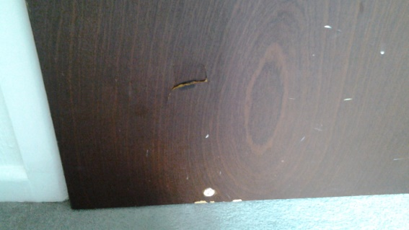
Door in guest room showing damage.

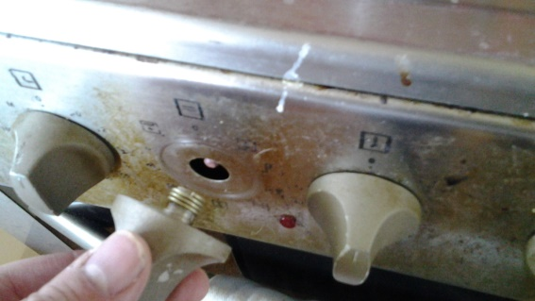
Oven knob loose.
Mould on ceiling.

