Asbestos Management Report

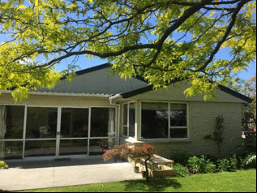

  - Fictional childcare centre
Prepared for | Bob
Contact Details | 0212345678  Bob@email.com
Site Address | 45 imaginary road

HELLO

Contents
Contents 2
Introduction 3
Inspection Instruction 3
Procedures 3
Inaccessible Areas 3
Site 4
Inspection Details 6
Summary of Non-Asbestos Containing Areas 6
All Survey Data 7
Samples 7
Sample S - S001 7
Presumed P - S002 8
Other Areas 9
Presumed asbestos P - S003, Ground, Outside 9
Recommendations 9
Asbestos Containing Materials 10
Appendix: Material and Priority scoring 1

Introduction
Your standard text goes here!

Inspection Instruction
Your standard text goes here!
As asbestos management survey was carried out at the request of Bob. Sampling was carried out in accordance with the guidelines set up in the LEGISLATION Health & Safety Executive document 'Asbestos', The Survey Guide' HSG264 (2012). The survey was conducted by a holder of qualification IP 402 (BOHS - Surveying & Sampling Strategies for Asbestos in Buildings) All safely accessible areas of the subject premises were surveyed for materials suspected of containing asbestos.

Procedures
Your standard text goes here!
This assessment included a visual inspection including some limited destructive sampling to selected parts of the internal and external areas of the subject buildings. Access to the external parts of the building was achieved from ground level, internal floors, from the roof or by specialist access equipment where required.
Photographs were taken of sampled materials and are included in Section 2 – Sampling Documents
Samples of suspected ACMs were collected, labelled and placed in double self-sealing bags and sent to an IANZ Accredited laboratory for analysis. The results of testing are included at Section 3 - Laboratory Analysis Results
All locations where samples were removed were marked with an adhesive label stating 'Danger - This material may contain asbestos'

Inaccessible Areas
Your standard text goes here!
There were a number of areas which were inaccessible due to: either specialist equipment was needed for access, would have caused damage to decoration, fixtures and fittings or the structure of the building.
Areas that required the attendance of a specialist engineer was not carried out.
A summary of inaccessible areas is available in Section 3 – Other Areas.

Site
The property being inspected is located at 45 imaginary road.
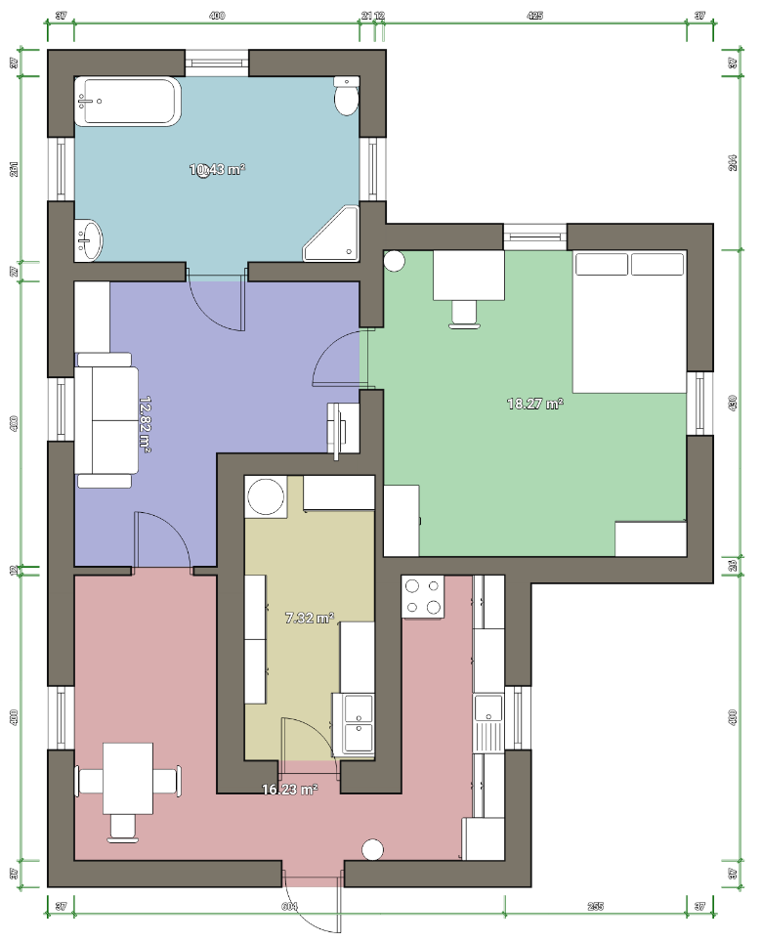
Photo showing bounds of property.

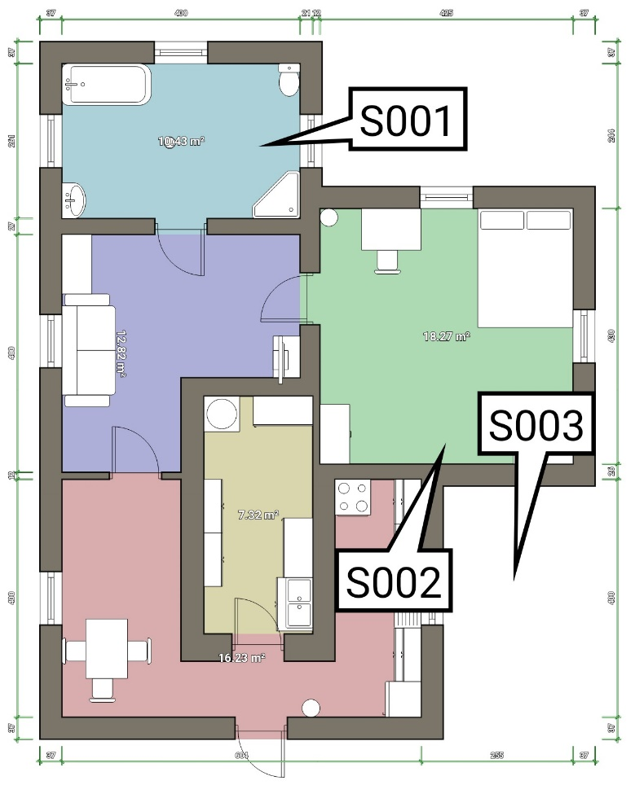
Floor plan with sampling points marked

Inspection Details
Site Name: | Fictional childcare centre | Site Address | 45 imaginary road
Client Name | Bob | Contact Details | 0212345678  Bob@email.com
Job Number | 52465 | Building | Main hall
Completed by |  | Date of Inspection | 08-Mar-2020
Staff Contact

Summary of Non-Asbestos Containing Areas
Location | Sample | Material Sampled | Condition | Quantity | Asbestos Type
Floor: Ground, Kitchen, Cupboarf | Presumed  P - S002 |  |  |  | Awaiting lab results0

All Survey Data

Samples

Sample S - S001

Location: | Wall | Floor/Level: | Ground
Room/Area: | Main room | Sample Number: | SS001
Sample Date: | 08-Mar-2020 | Material Type: | Wood frame

Photo of context location | Photo of sample

Product Type | Asbestos reinforced composites | Asbestos Type | Brown (Amphibole asbestos excluding crocidolite) and mixtures (not blue)
Ease of Access | Easy | Comments on Area/Accessibility
Surface Coating | Painted | Condition | Fair
Friable? | Potentially friable | Quantity | 15m²

RISK ASSESSMENT
Material Assessment |  | Priority Assessment
Product Type | 1 | Activity | 2 | Number of Occupants | 2
Extent of Damage/deterioration | 2 | Location | 2 | Frequency of use of area | 2
Surface Treatment | 0 | Accessibility | 1 | Average time area is in use | 1
Asbestos Type | 2 | Extent/amount | 2 | Type of maintenance activity | 0
 |  |  |  | Frequency of maintenance activity | 0
Material Total: | 5.0 | Priority Total: | 5.3 | Risk Total: | 10.3

Comments
No comment recorded.

Presumed P - S002

Location: | Cupboarf | Floor/Level: | Ground
Room/Area: | Kitchen | Sample Number: | PS002
Sample Date: | 08-Mar-2020 | Material Type:

Photo of context location | Photo of sample

Product Type |  | Asbestos Type | Awaiting lab results
Ease of Access | Moderate | Comments on Area/Accessibility
Surface Coating | Painted | Condition | Fair
Friable? | Potentially friable | Quantity

RISK ASSESSMENT
Material Assessment |  | Priority Assessment
Product Type | 0 | Activity | 0 | Number of Occupants | 0
Extent of Damage/deterioration | 0 | Location | 0 | Frequency of use of area | 0
Surface Treatment | 0 | Accessibility | 0 | Average time area is in use | 0
Asbestos Type | 0 | Extent/amount | 0 | Type of maintenance activity | 0
 |  |  |  | Frequency of maintenance activity | 0
Material Total: | 0.0 | Priority Total: | 0.0 | Risk Total: | 0.0

Comments
No comment recorded.

Other Areas

Presumed asbestos P - S003, Ground, Outside
Location: | Driveway | Material Containing Asbestos? | Presumed asbestos
Notes on area/accessibility:
No comments made.

Photo 1

Recommendations
Sample Number | Location | Recommendations
SS001 | Ground, Main room  Wall | Restrict access and remove

Asbestos Containing Materials
Sample | Location | Material Type and Quantity | Asbestos Type | Ease of access | Risk Rating | Condition | Friable?
Sample  S - S001 | Floor: Ground, Main room, Wall | Wood frame, 15m² | Brown (Amphibole asbestos excluding crocidolite) and mixtures (not blue)2 | Easy | 2 10.3 2  2 1  1 0  2 2  2  2  1  0  0 | Fair | Potentially friable
Presumed asbestos  P - S003 | Floor: Ground, Outside, Driveway | UNKNOWN | Presumed Crocidolite (Blue) | No comments made. | 3 | UNKNOWN | UNKNOWN

ADDITIONAL PHOTOS
Figure 1 - Vinyl carpet

Appendix: Material and Priority scoring
Your standard text goes here!
The following is from the UK HSE HSG264 guidelines.
Material Score | Potential to release asbestos fibres
10 or more | High
7-9 | Medium
5-6 | Low
4 or less | Very low

See UK HSE HSG 264 and other resources – add your own guidance notes as you want here....
Your standard text goes here!

