Project: Warehouse refurbishment | Project Ref: PRJ-123456
Client: Bostock Warehousing | Client contact: Clive, 021 345 567
Site Address: 45 Greensward Avenue, Christchurch | Date on Site: 27-May-2019
Applicator Company:  Bob Painter | Job Specification:  TG5647
Temp at start: 25°C | Humidity at start: 18%
Meter ref: PSK5678

Ground floor
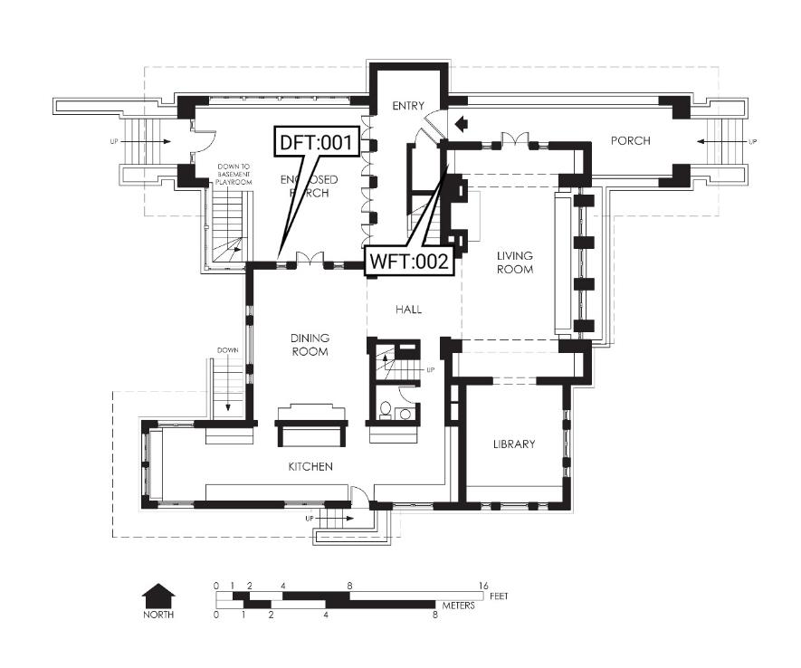

Film Inspections
Ref: Dry Film: 001
Time: 5:04 pm | Location: Kitchen
Primer, Tar | Min: 25 μm | 32 μm
Readings: 25 | Max: 39 μm
Readings batch: Yg6788 | Std Dev: 5

Comments
Nice
Remedial Actions
Do it again

Ref: Wet Film: 002
Time: 5:10 pm | Location: Lounge
Applicator's Name: Bob |  | Thickness
Temperature: 26 °C |  | 250 μm
Humidity: 19 %

Comments
Nice!
Remedial Actions
No action required
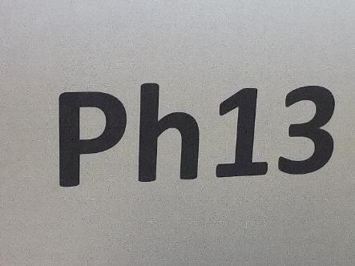

Ref: Dry Film: 003
Time: 5:04 pm | Location: Kitchen
Intermediate, Tar | Min: 25 μm | 32 μm
Readings: 25 | Max: 39 μm
Readings batch: Yg89788 | Std Dev: 5
Meter used: GH678

Comments
Nice
Remedial Actions
Do it again
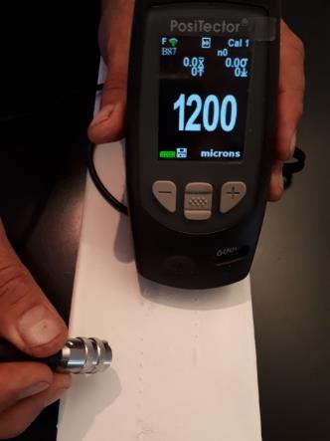
Altex Coatings Ltd

Ref: Wet Film: 005
Time: 5:10 pm | Location: Lounge
Applicator's Name: Bob |  | Thickness
Temperature: 26 °C |  | 250 μm
Humidity: 19 %

Comments
Nice!
Remedial Actions
No action required
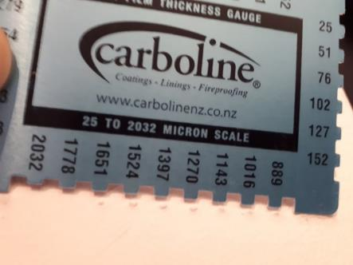
Altex Coatings Ltd

Additional Photos
Figure 1 - Wall | Figure 2 - Ceiling

